Ass 01: Rock Paper Scissors
IT 1090C/6090C Computer Programming I
Prof. Jason Geanuracos
Fall 2025

Ass 01: Rock Paper Scissors
20 Points

This is your first assignment. Unlike the labs, you will complete the assignment on your own. You are welcome to reach out for assistance or guidance.
Assignments are due in two weeks and have a one-week grace period from the due date just like the labs.

Mini-Lecture: Comparing Strings for equality
Recall that String is an Object type in java unlike the other primitive types we have seen. (Scanner is also an Object type as is Random.)
So, you can’t use == to test if two strings are equal.
You can’t use == with any object to test for equivalence. What it actually does is test to see if the two object references refer to the same location in memory. In other words, if they are different names for the same object!
To test for equivalence with two different Strings, we use .equals() and .equalsIgnoreCase()
if (partyAfil.equals(“R”)) // only matches uppercase R
or
if(partyAfil.equalsIgnoreCase(“R”)) matches upper or lowercase R r

Assignment
Screenshot shortcut keys
- Windows: Alt + printScrn key puts image of desktop in clipboard. Then paste (ctrl+v) it into the document. You can also use Opt (Start) + Shift + s to bring up a cropping tool and paste that into your document. This may be easier. Also, you can hit Start + v to bring up the clipboard if you would like to screenshot multiple pictures and then paste all at once.
- Mac: Shift + Command + 3 or Shift + Command + 4 to capture a portion of the screen. Then, paste (command + v) it into the document.

- Create an IntelliJ project file named Ass01_RockPaperScissors and add it to GitHub.
- Code the Rock Paper Scissors program:
  - Get a move choice from playerA which must be R, P, S or r, p, s
Loop until you get a valid move
  - Get a move choice from playerB in the same manner
  - Display the results using the accepted phrases from the game
Rock breaks Scissors,
Paper covers Rock,
Scissors cuts Paper
and indicate the winner (Player A wins) or
Rock vs Rock it’s a Tie! Etc…
  - Prompt the user to play again [Y/N]
  - Continue or terminate based on the user’s choice.
- Be sure to commit and push your code to the GitHub repo

- To assist in grading the work efficiently, I will ask you to provide screen capture shots of your program runs to show that you completed the assigned work. Provide the following screen shots. Insert them here.
- Show the looping when the user fails to enter a valid move.
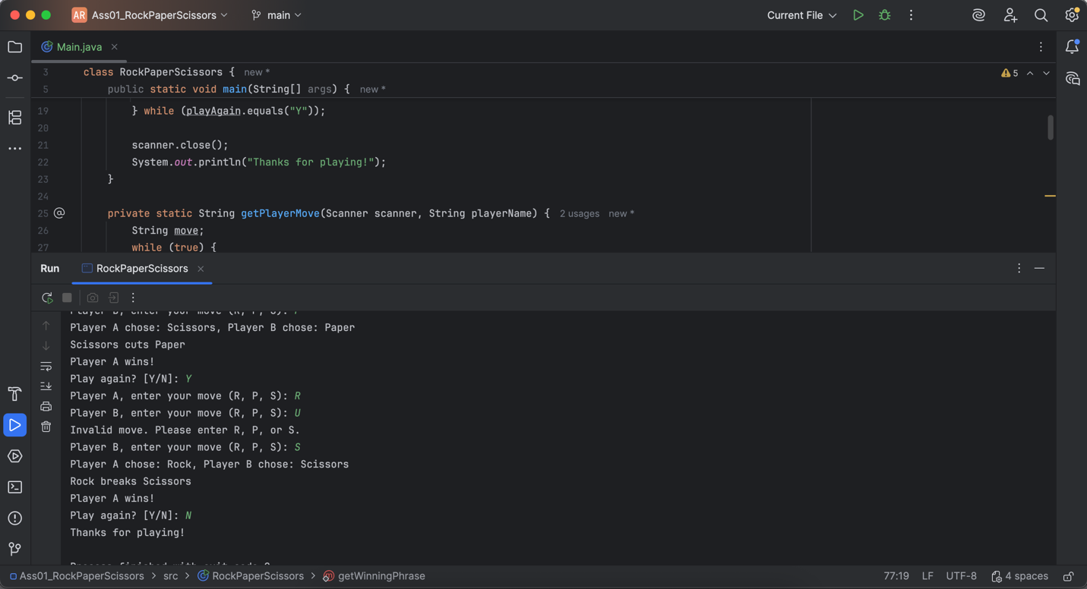
- Show several (3) completed games and the prompt to play again.
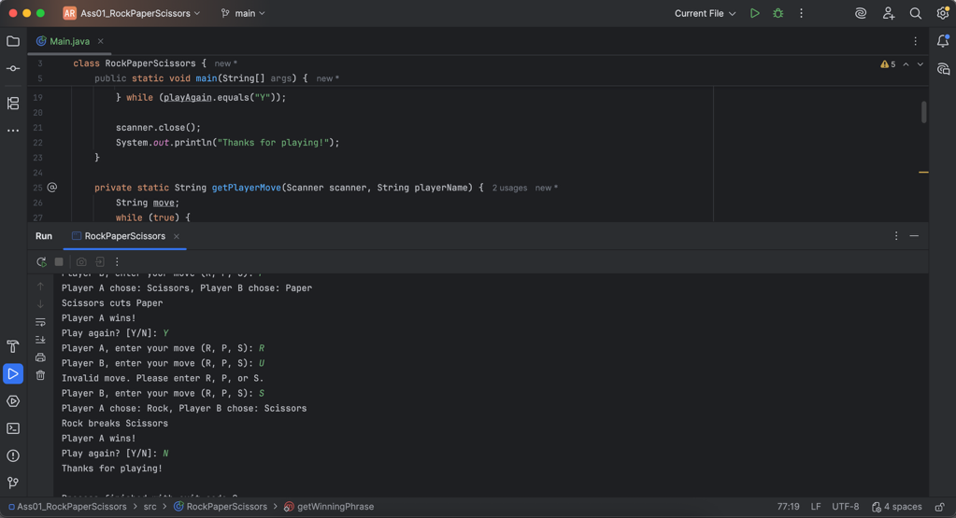
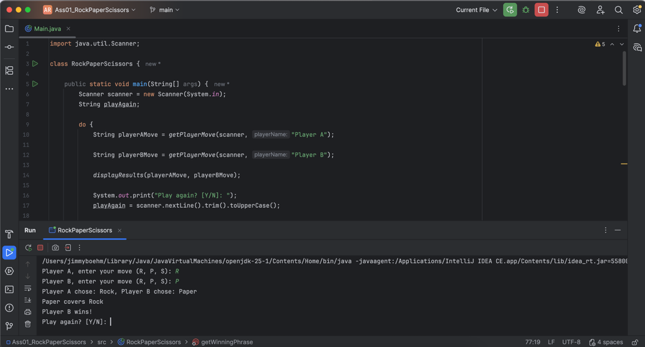

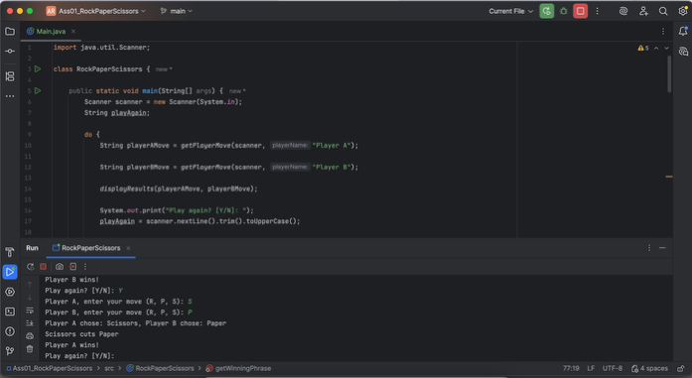

Post-Lab: Double-check Your Work
Now that you have completed the lab tasks, build constructive professional work habits by carefully rechecking your work, and abiding by the naming format and submission instructions.

Rename this file
Use the YourLastname_YourFirstname_Ass01_RockPaperScissors.docx format to rename this MS Word docx; remember to replace "YourLastname" and "YourFirstname" with your actual names.

GitHub:
Provide/Paste the link to your GitHub repo.
https://github.com/boehmjs/Ass01_RockPaperScissors

Submit
Submit to Canvas using the assignments mechanism to upload your document. Don’t submit a link to your document.

